Experiment No. 12
Implementation of Tic-Tac-Toe Game Using Python
Question: Write a Python program to implement the Tic-Tac-Toe game.
Aim: To develop a Tic-Tac-Toe game using Python in which two players play alternately, and the program identifies the winner or a draw.
Algorithm:
- Start the program.
- Initialize a 3 × 3 game board.
- Display the game board.
- Accept the current player's move.
- Check whether the selected position is valid and empty.
- Place the player's symbol (X or O) on the board.
- Check whether the current player has won.
- If all positions are filled and there is no winner, declare a draw.
- Otherwise, switch to the next player and repeat the steps.
- Stop the program when the game ends.
Code:
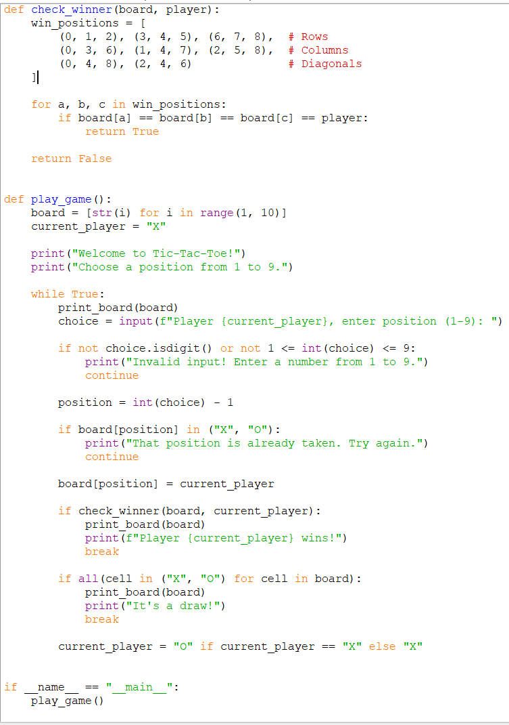

Output:
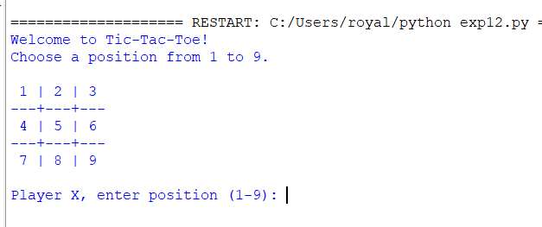

Result: The Tic-Tac-Toe game was successfully implemented using Python.

